

Cal State LA University

Re_ admit Historical

By: Bita Sadat Faraji Tabrizi

**Introduction**

A hospital readmission is when a patient who had been discharged from a hospital is admitted again to that hospital or another hospital within a specified time frame. Readmission rates have increasingly been used as an outcome measure in [health services research](https://en.wikipedia.org/wiki/Health_services_research) and as a quality benchmark for health systems. Hospital readmission rates were formally included in reimbursement decisions for the [Centers for Medicare and Medicaid Services](https://en.wikipedia.org/wiki/Centers_for_Medicare_and_Medicaid_Services) (CMS) as part of the [Patient Protection and Affordable Care Act](https://en.wikipedia.org/wiki/Patient_Protection_and_Affordable_Care_Act) (ACA) of 2010, which penalizes health systems with higher than expected readmission rates through the Hospital Readmission Reduction Program.

**Goals**

This study goal is to provide an analysis of readmission history in 10 different states of Florida, Alabama, Georgia, Texas, Virginia, Illinois, Mississippi, Arkansas, Missouri, and Tennessee.

The relationship between certain variables are studied using correlation matrix. These variables are Admit Length of Stay, Readmit Length of Stay, Number of Chronic Conditions, Number of visits, Readmitted, and Order Total Charges. The analysis that is performed shows the trends and will further help with achieving the goal of this study.

Furthermore, this study will show number of visits by states, departments, and gender. It also helps with solving the problem of readmission.

**Data explorer**

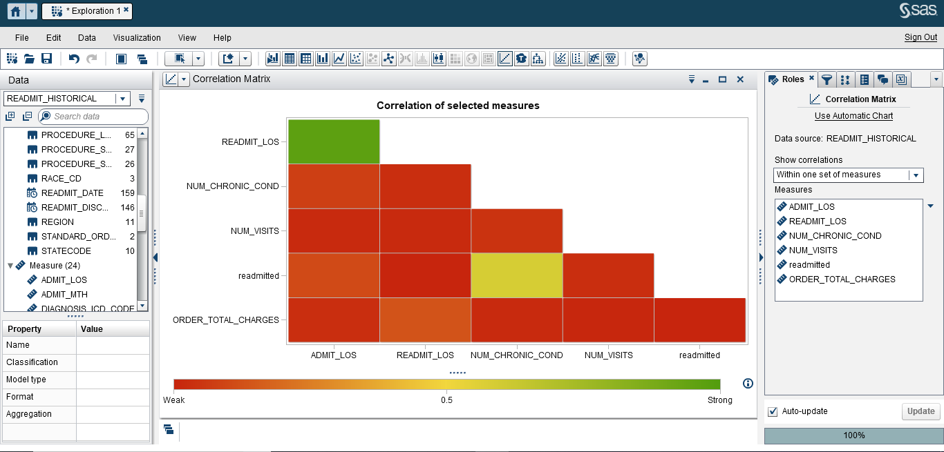

The correlation matrix of Admit Length of Stay, Readmit Length of Stay, Number of Chronic Conditions, Number of visits, Readmitted, and Order Total Charges is shown above. The color gradient Red-Yellow-Green is used in this visualization. As it can be seen there is a strong relationship between Readmit Length of Stay and Admit Length of Stay. There is also a moderately strong relationship between Readmitted and Number of Chronic Conditions. But the rest have weak relationships between them.

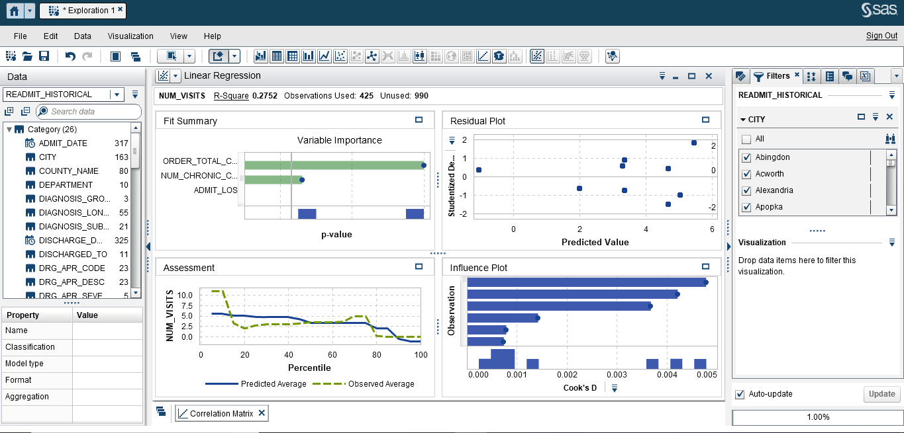

The linear regression of Number of visits, for Number of Chronic Patients, Admit Length of Stay, Order Total Charges and Readmit Length of Stay is shown above. The linear regression shows the best fitted line. R-squared is a statistical measure of how close the data are to the fitted regression line. In this visualization R-squared is 0.2752, which means twenty seven percent of the variability of response data is around its mean. Moreover, the visualizations is filtered by cities starting with letter “A”.

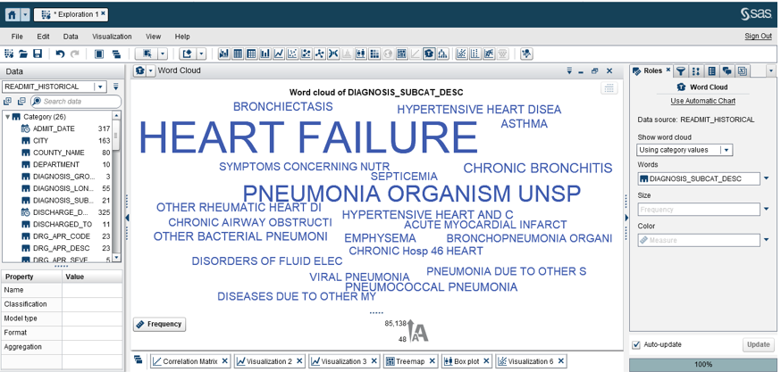

The word cloud showing the frequency of words used in Diagnosis Subcat Desc is seen above. It can be observed that “Heart Failure” has the highest frequency of 85,138, as it’s written with the largest font. The “Pneumonia Organism Unsp” has the second largest frequency of 31,245.

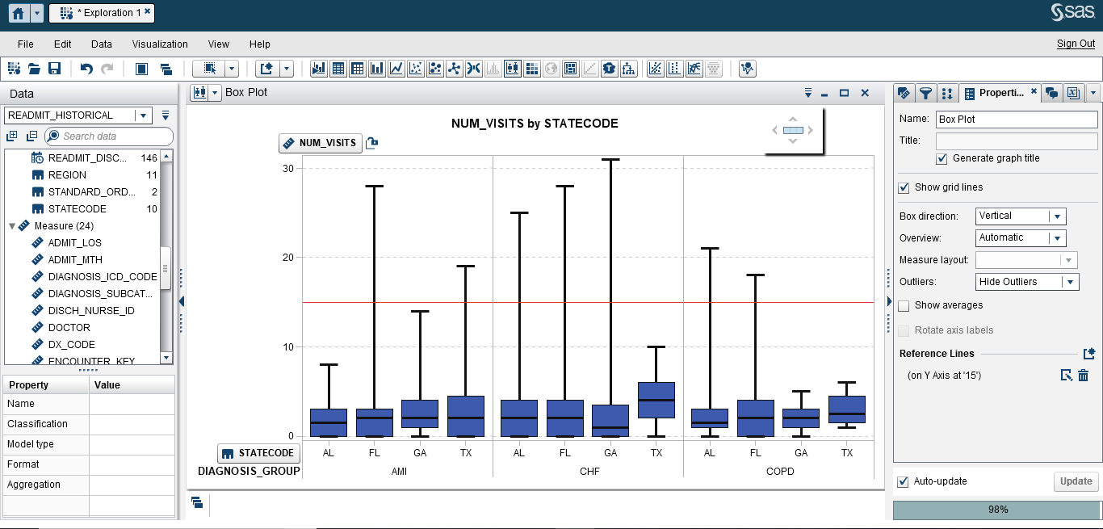

The box plot showing Number of visits by State code is seen above. In lattice column the diagnosis group is chosen to differentiate between the three diagnosis types. As it can be seen, for the AMI group “Florida” has the highest state code, while in CHF its “Georgia”, and in COPD its “Alabama”. A reference line on Y-axis at 15 is used to make differentiation easier.

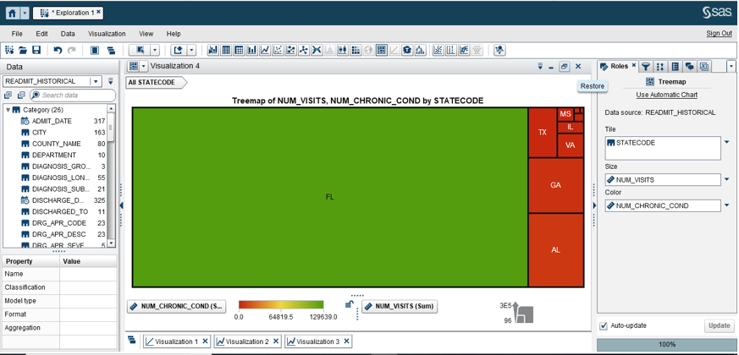

The tree map showing Number of visits and Number of Chronic Conditions by state code is seen above. It can be observed that “Florida” has the highest number of visits and Number of Chronic Conditions in all the 10 states. As it’s shown the color in tree map is based on Number of Chronic Conditions while the size is based on Number of visits.

**Report Designer**

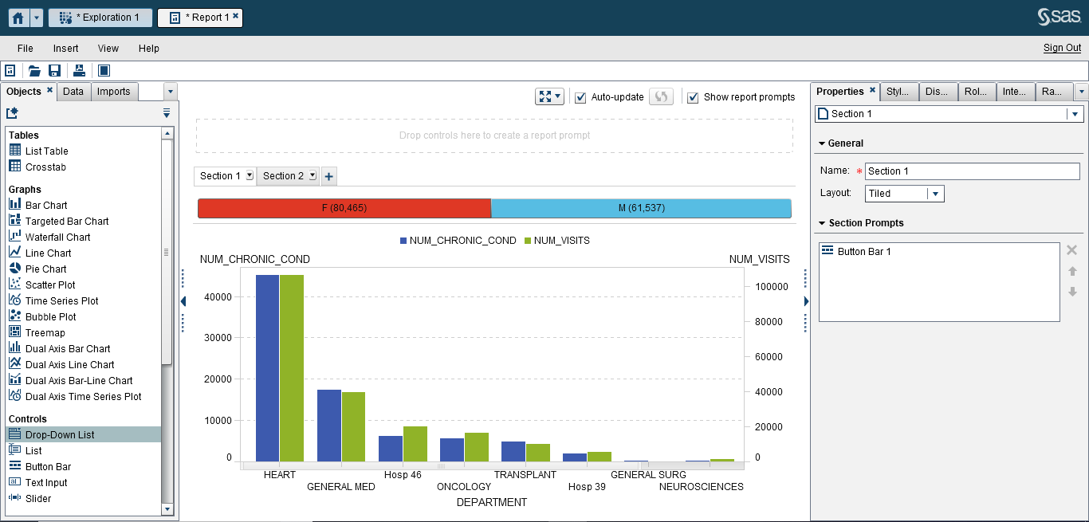

The dual axis bar chart showing Number of Chronic Conditions and Number of visits by department is seen above. It can be seen as the Number of Chronic Conditions increases the Number of visits increases as well. The “heart” department has the highest number in both categories. Also in control, button bar is used to differentiate between female and male statistics as shown above.

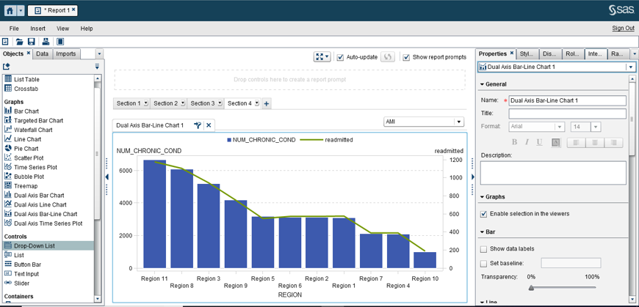

The dual axis bar-line chart showing Number of Chronic Condition and Readmitted by Region is shown above. Region 11 has the highest Number of Chronic Conditions followed by region 8. As it can be seen, the Number of readmitted decreases as the Number of Chronic Condition decreases. The drop-down list is used to filter it by diagnostic group.

**Summary/ Story telling**

The [readmission measures](https://www.medicare.gov/hospitalCompare/Data/data-updated.html#MG16) are estimates of unplanned readmission to an [acute care hospital](https://www.medicare.gov/hospitalcompare/data/30-day-measures.html) in the 30 days after discharge from a hospitalization.

Factors that may affect readmission: several factors that increase the likelihood of readmission may be modifiable, especially those that relate to clinician or system level issues. Such factors include:

●Premature discharge

●Inadequate post-discharge support

●Insufficient follow-up

●Therapeutic errors

●Adverse drug events and other medication related issues

●Failed handoffs

●Complications following procedures

●Nosocomial infections, pressure ulcers, and patient falls

Risk factors for readmission: several studies have suggested there are clinical and demographic parameters that may increase the risk of readmission. Risk factors may vary depending on the interval between discharge and readmission. A cohort study at a single institution found that risk factors for early readmissions (within one week after discharge) were somewhat different than risk factors for later readmissions (between 8 and 30 days after discharge).

Clinical factors:

●Use of high-risk medication (antibiotics, glucocorticoids, anticoagulants, narcotics, antiepileptic medications, antipsychotics, antidepressants, and hypoglycemic agents)

●Polypharmacy

●More than six chronic conditions

●Specific clinical conditions (eg, advanced chronic obstructive pulmonary disease, diabetes, heart failure, stroke, cancer, weight loss, depression, sepsis)

Demographic and logistical factors include:

●Prior hospitalization, typically including unplanned hospitalizations within the last 6 to 12 months

●Black race

●Low health literacy

●Reduced social network indicators (eg, being alone most of the day with limited or no family or friend contact by phone or in person)

●Lower socioeconomic status

●Discharge against medical advice

To reduce the number of hospital readmissions, the Hospital Readmissions Reduction Program (HRRP) was used. This is a Medicare value-based purchasing program that reduces payments to hospitals with excess readmissions. The program supports the national goal of improving healthcare for Americans by linking payment to the quality of hospital care.

In the 2010 to 2016 period, raw rates of readmission fell for each condition covered by the HRRP (Figure 1-3). Of the conditions initially included in the HRRP, AMI saw the largest decline in raw rates of readmission during that period, falling from 19.0 percent to 15.4 percent. Readmission rates for heart failure also declined substantially, falling from 23.6 percent to 20.6 percent. Pneumonia, the third condition initially covered by the HRRP, also saw a sizable decline, falling 2.3 percentage points.

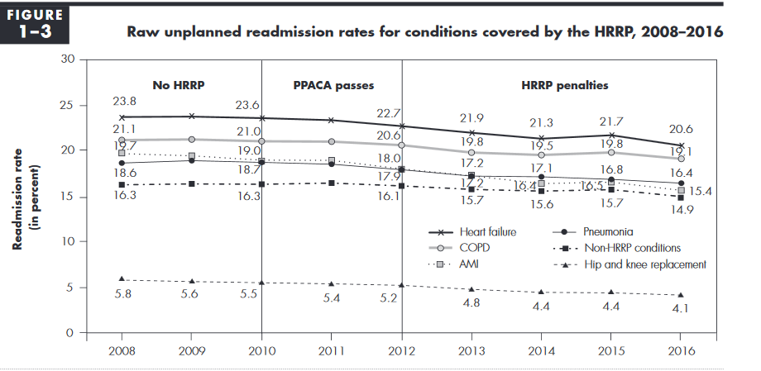

The figure above in fact gives the same result as obtained from report 1, showing that heart department has the highest number of visits.

To reduce Hospital Readmission Rates/ Costs the following has to be done:

* Identify root cause of hospital readmission: Understanding why a patient returns to the hospital after discharge is key to preventing readmissions and solving challenges of follow-up care.
* Optimize transitions of care: Ineffective care transitions following a hospitalization increase the rates and costs of hospital readmissions.
* Improve patient engagement and education: Inadequate patient and caregiver communication is another barrier to effective care transitions and hospital readmission reduction initiatives, the Joint Commission stated.

**References:**

Alper, E. & O'Malley T. & Greenwald J. (2017, Dec 19). Hospital discharge and readmission. Retrieved from <https://www.uptodate.com/contents/hospital-discharge-and-readmission>

LaPointe, J. (2018, Jan 8). 3 Strategies to Reduce Hospital Readmission Rates, Costs. Retrieved from <https://revcycleintelligence.com/news/3-strategies-to-reduce-hospital-readmission-rates-costs>

Mandated report: The effects of the Hospital Readmissions Reduction Program [PDF file]. (2018, June). Retrieved from <http://www.medpac.gov/docs/default-source/reports/jun18_ch1_medpacreport_sec.pdf>

Hospital Readmissions Reduction Program (HRRP). (2019, Jan 16). Retrieved from <https://www.cms.gov/medicare/medicare-fee-for-service-payment/acuteinpatientpps/readmissions-reduction-program.html>

30-day unplanned readmission and death measures. (n.d). Retrieved from <https://www.medicare.gov/hospitalcompare/data/30-day-measures.html>

Hospital readmission. (2019, Feb 17). Retrieved from <https://en.wikipedia.org/wiki/Hospital_readmission>